Hello from the friendly skies. We are currently on the way to JFK where we’ll catch our overnight flight to Brussels. I don’t remember if I blogged about this or not but we booked two separate flights from Charlotte to JFK and then JFK to Brussels and saved $1,000. The direct flights from Charlotte were crazy expensive and had two stops – Toronto (with a LONG layover!) and London. We’ll have to claim our baggage and re-enter the airport and go through security in JFK but it’s totally worth it for the savings.

Although I was running around getting last-minute shopping and errands done, this short week before vacation actually wasn’t bad. I ended up subbing out my Tuesday 9:30 a.m. class so I could have an uninterrupted work day and was able to clean out my inboxes and also pre-write two posts that will go live while I’m gone! I felt totally calm and organized packing and leaving the house, Tanner and I even fit in a sunrise yoga class at the studio this morning before we did our final preparations!

A few scenes from the week and then we’re off!

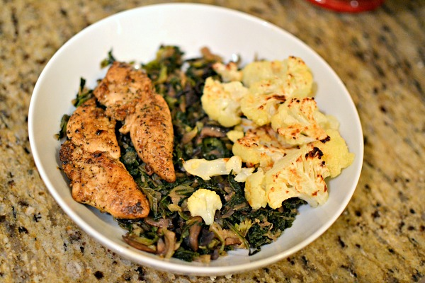

Monday night dinner was leftovers with roasted cauliflower.

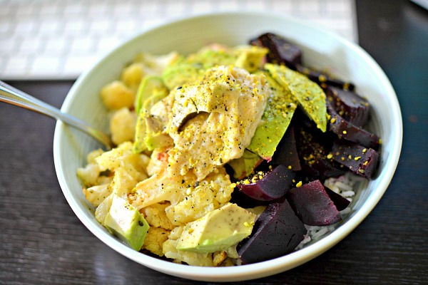

Lunch Monday and Tuesday was rice bowls with beets, avocado, hummus, roasted cauliflower and Be Runa Curry Seed Salt.

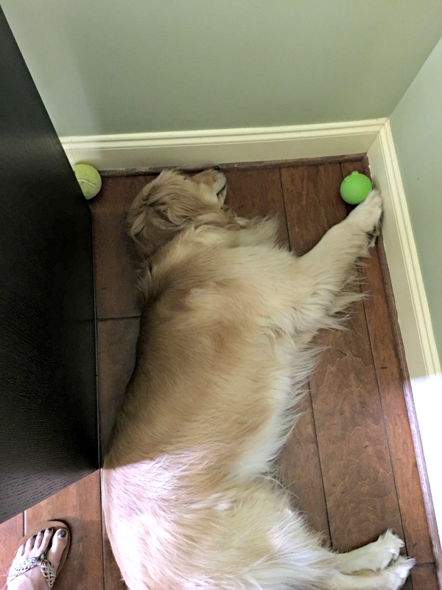

Just a girl and her balls lying in a corner. What else is new!?

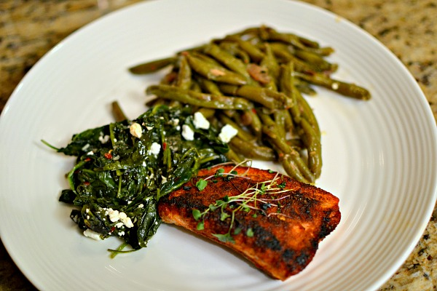

Takeout from Namastay. BBQ-rubbed salmon, sautéed spinach and green beans.

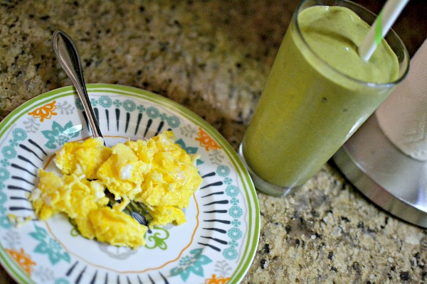

After yoga this morning I took the girls for a short walk and then made breakfast for Tanner and I. Two eggs scrambled in coconut oil and the smoothie I blogged about last week with avocado added.

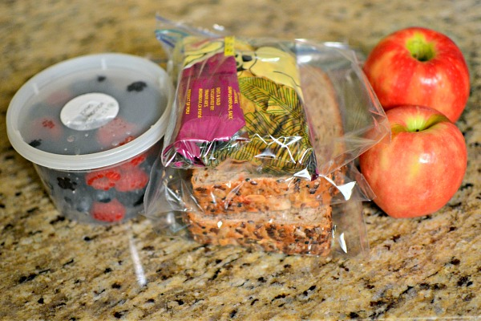

Lunch and snacks for the plane. It’s a loonnnggg travel day and I wanted to pack a lunch from home before having to eat airport/airline food for the next couple of meals.

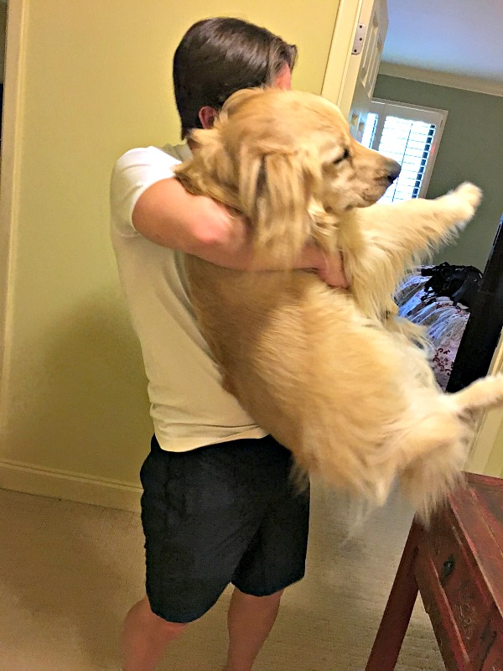

Tanner and Zoey having a moment before we left.

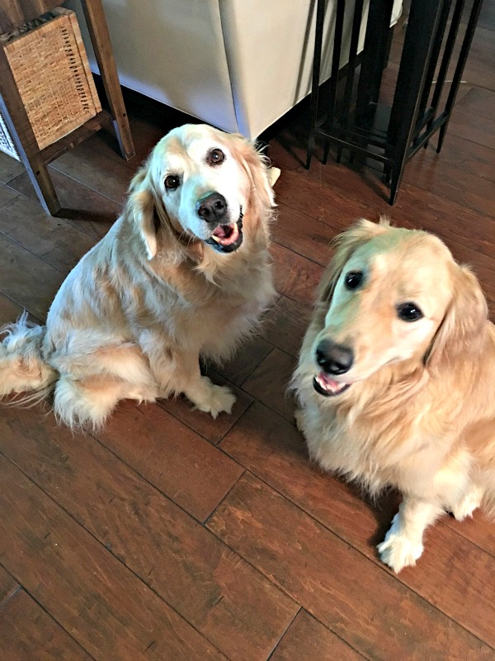

I always get a little sad to say goodbye to these sweet things. Luckily, we have an awesome pet sitter who is also a friend and employee of ours so they are in the best care.

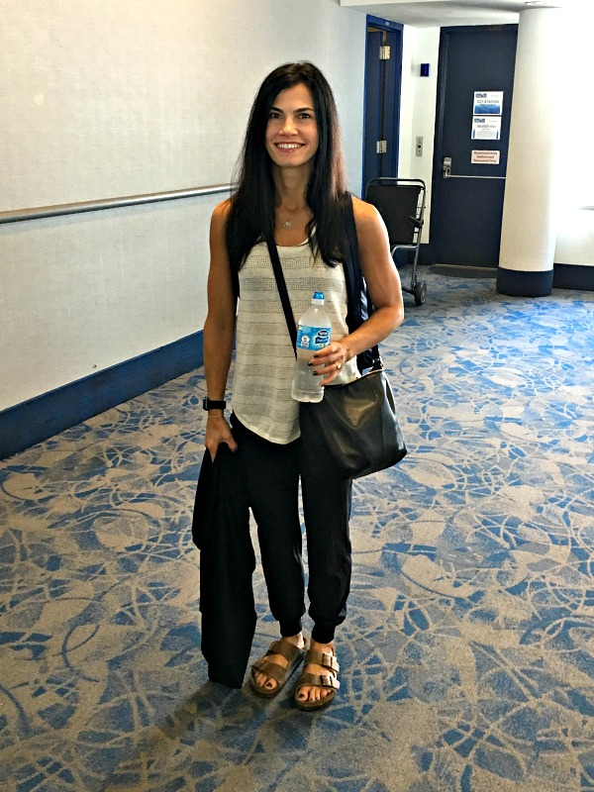

Getting ready to board our flight to JFK. I decided to go with the traditional Birkenstocks but more on that later. It was quite the dilemma!

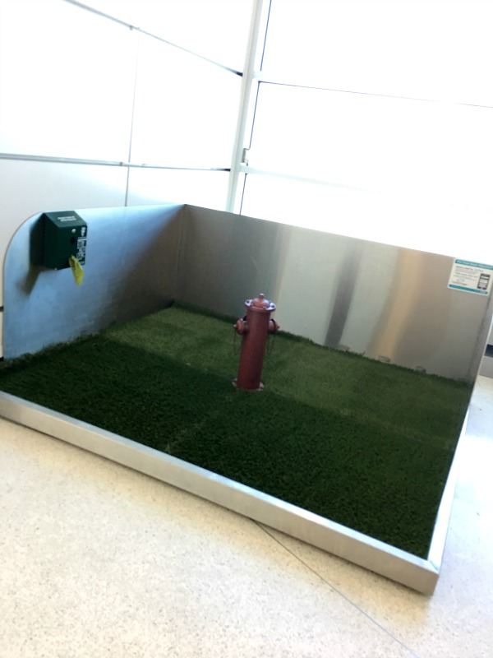

I had to snap a picture of this dog station in the CLT airport! How crazy is this!? I guess it’s for the service dogs and people traveling with small dogs?

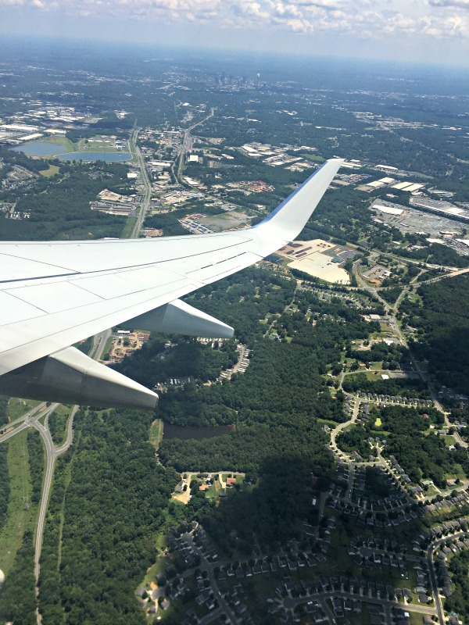

Goodbye Charlotte…see you next week. (You can see the skyline in the background.)

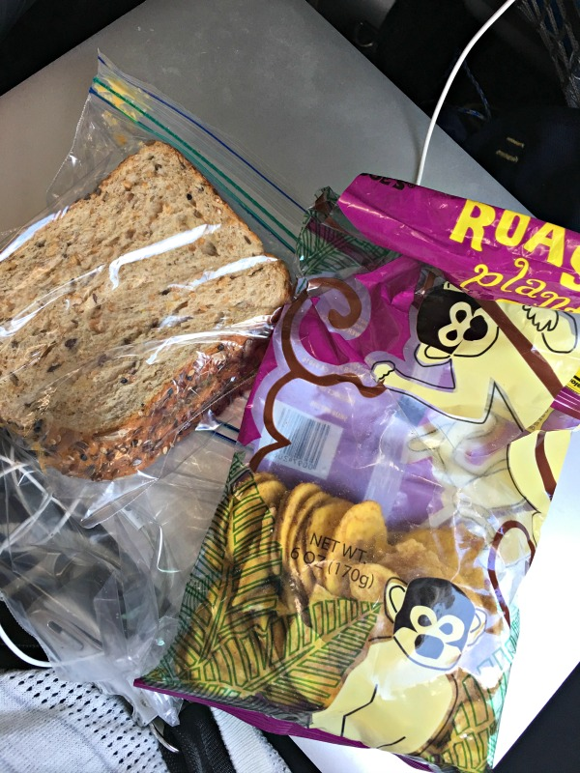

And one can never go wrong with a PB&J!

